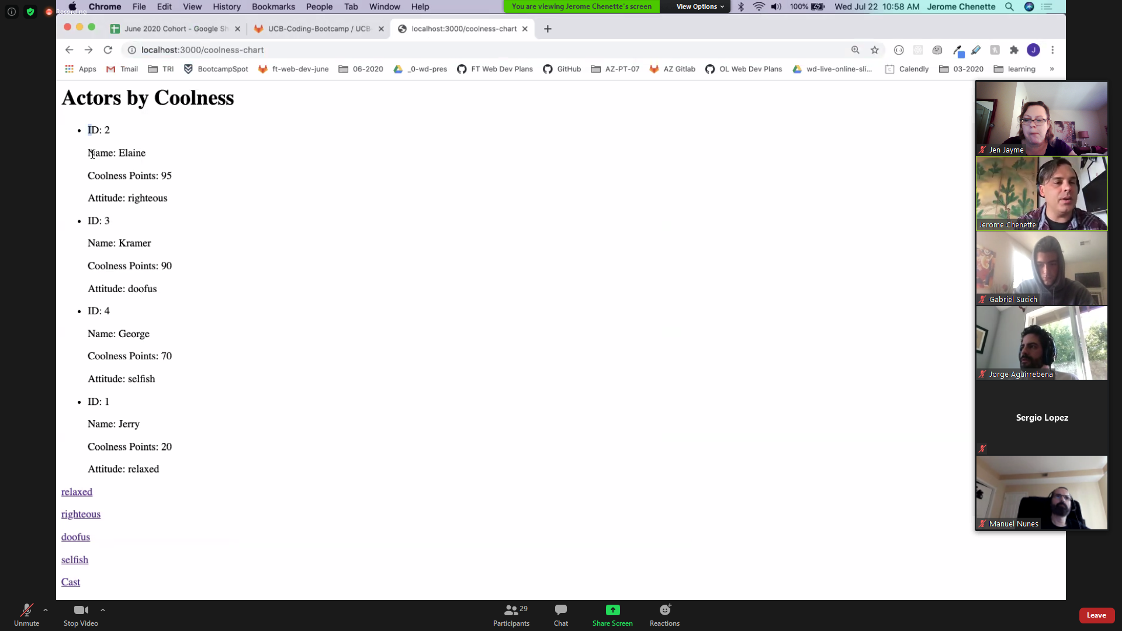

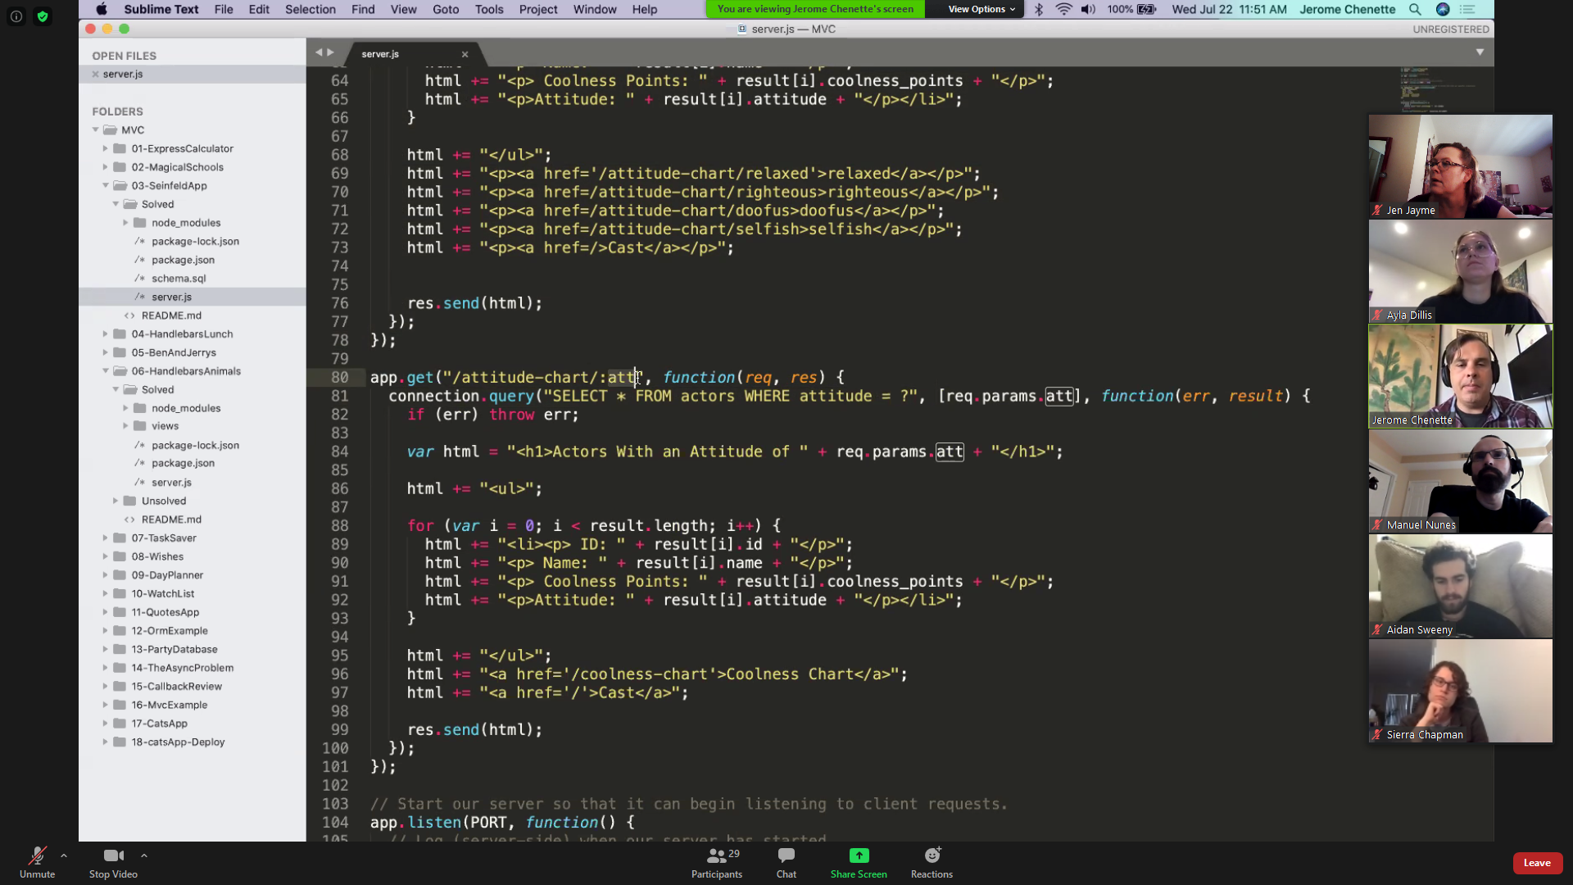

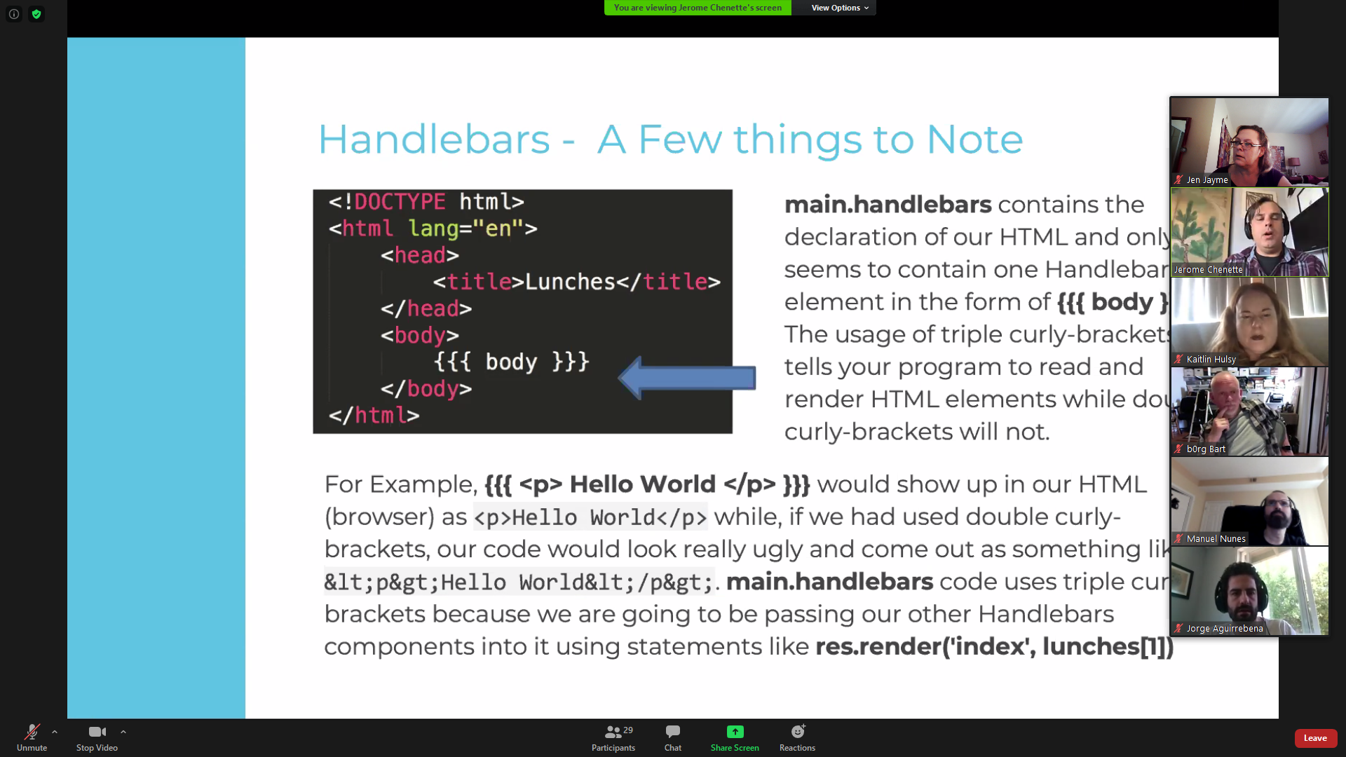

{{{body}}} triple curly braces = placeholder for handlebars

{{}} double stashes will be used on your template

Check Express module for built-in methods for express responses, esp res.render(“index”, lunches[0]); “index” is template, “lunches[0]” is what it’s going to render (an object)

With handlebars, must use their folder layout system with views/layouts

var lunches = [

{lunch: sandwich},

{lunch: soup}

]

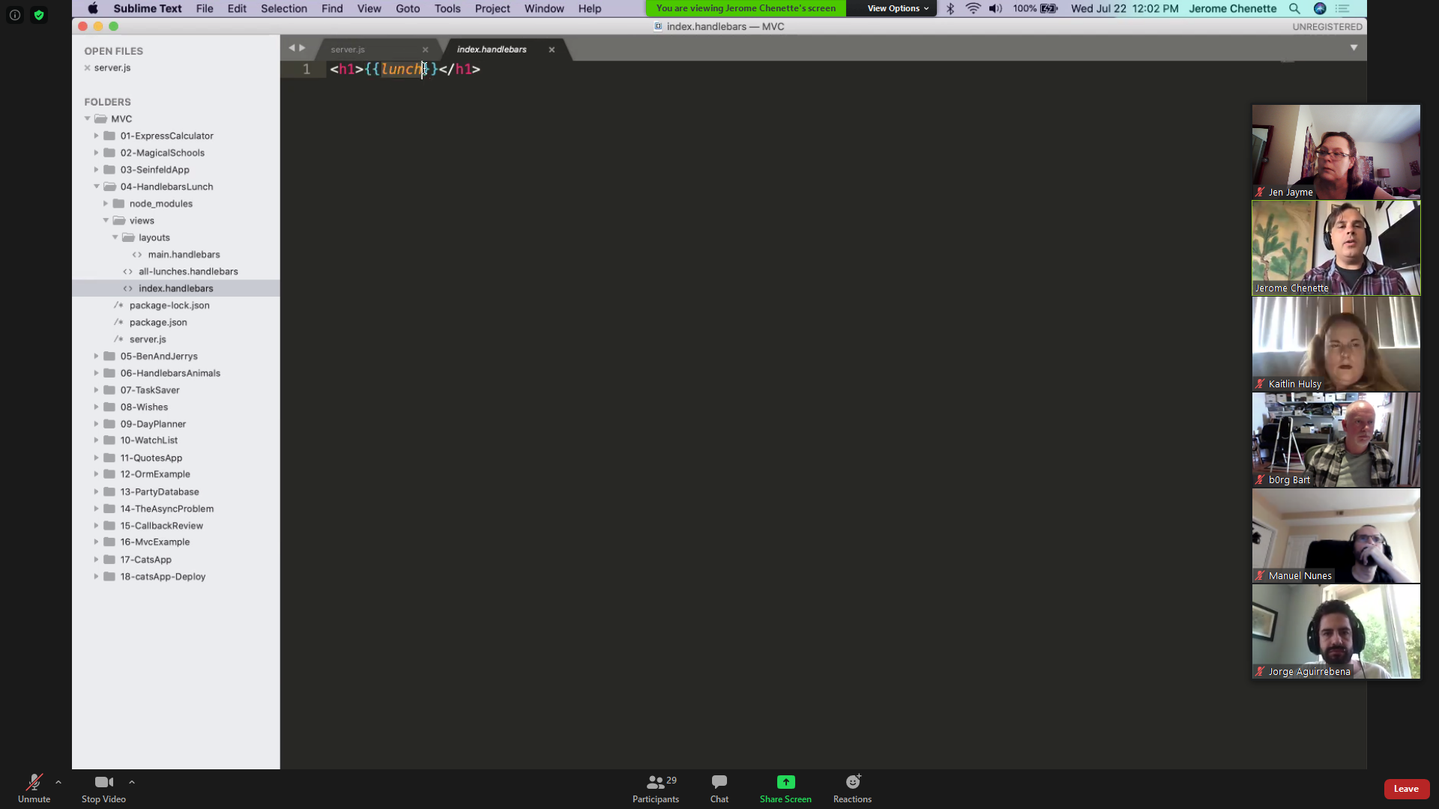

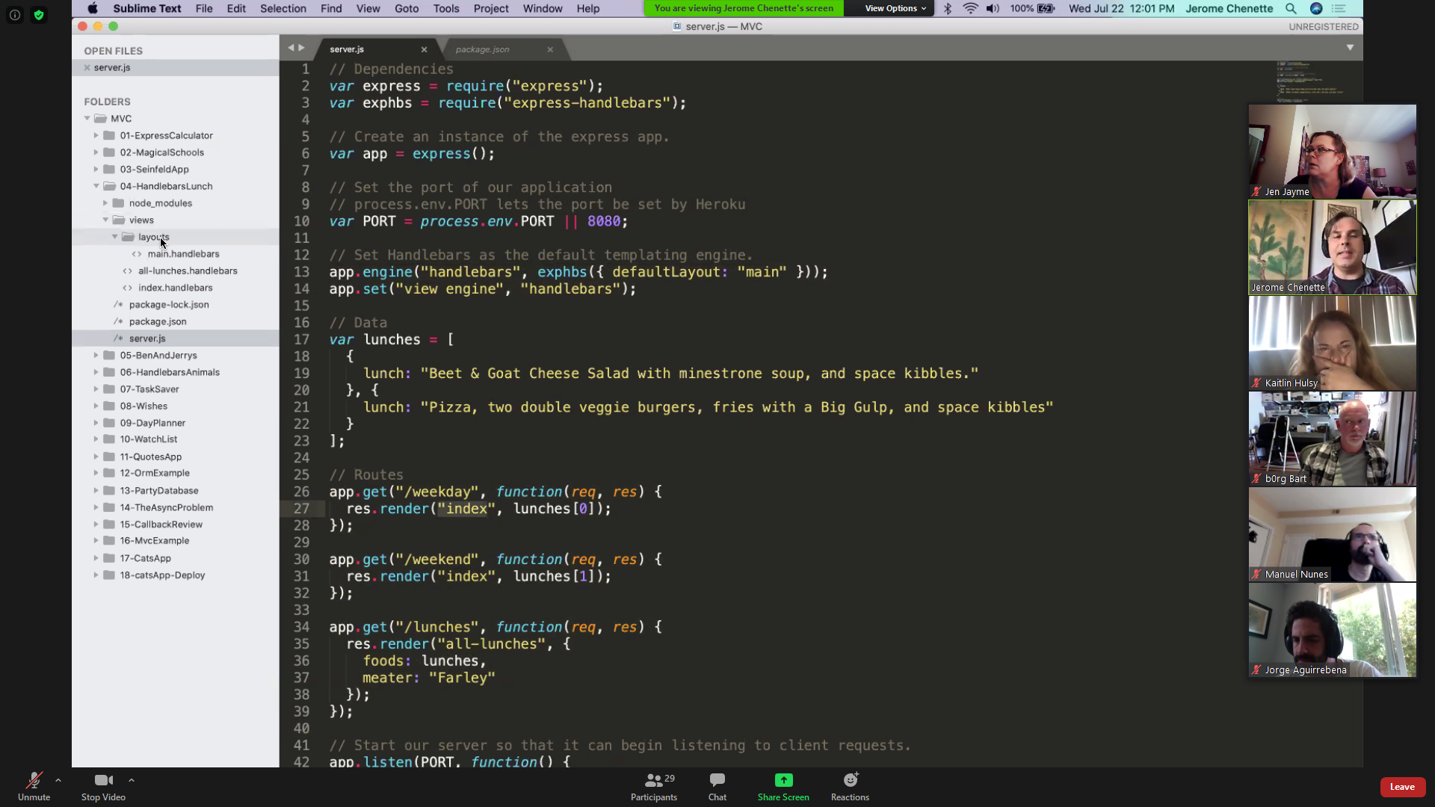

TEMPLATE:

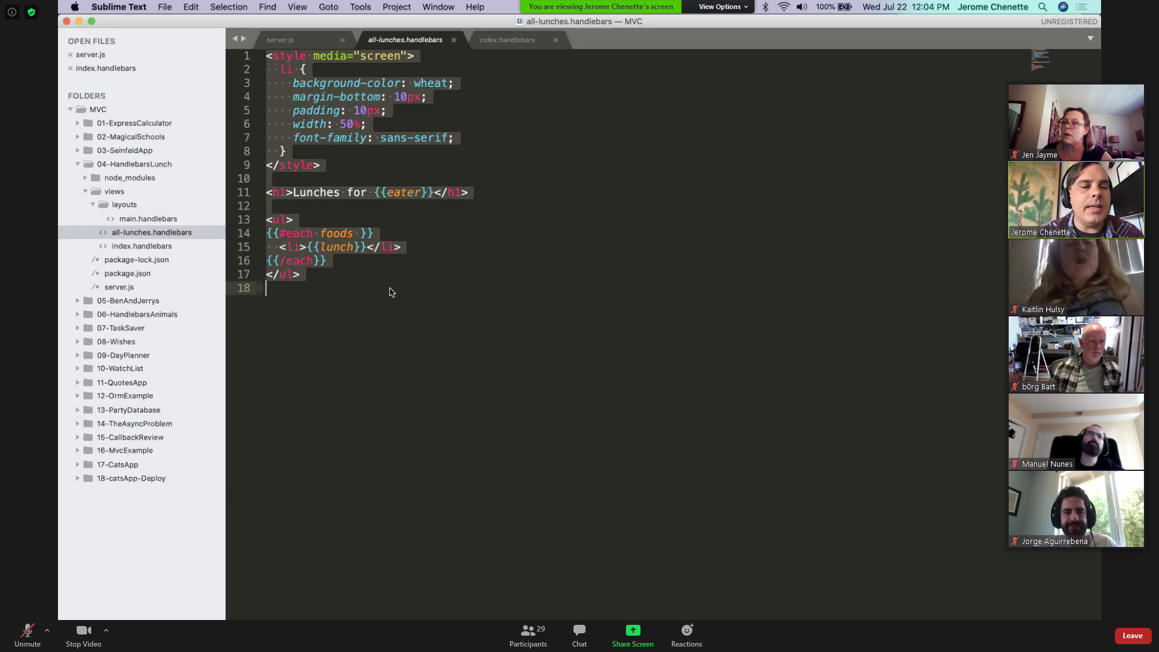

TEMPLATE VS SERVER.JS

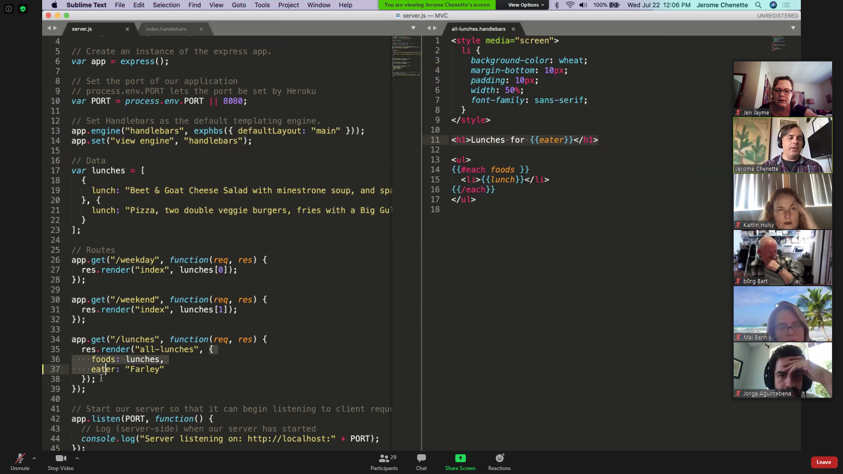

BEN & JERRY’S ACTIVITY SHOULD LOOK LIKE THIS:

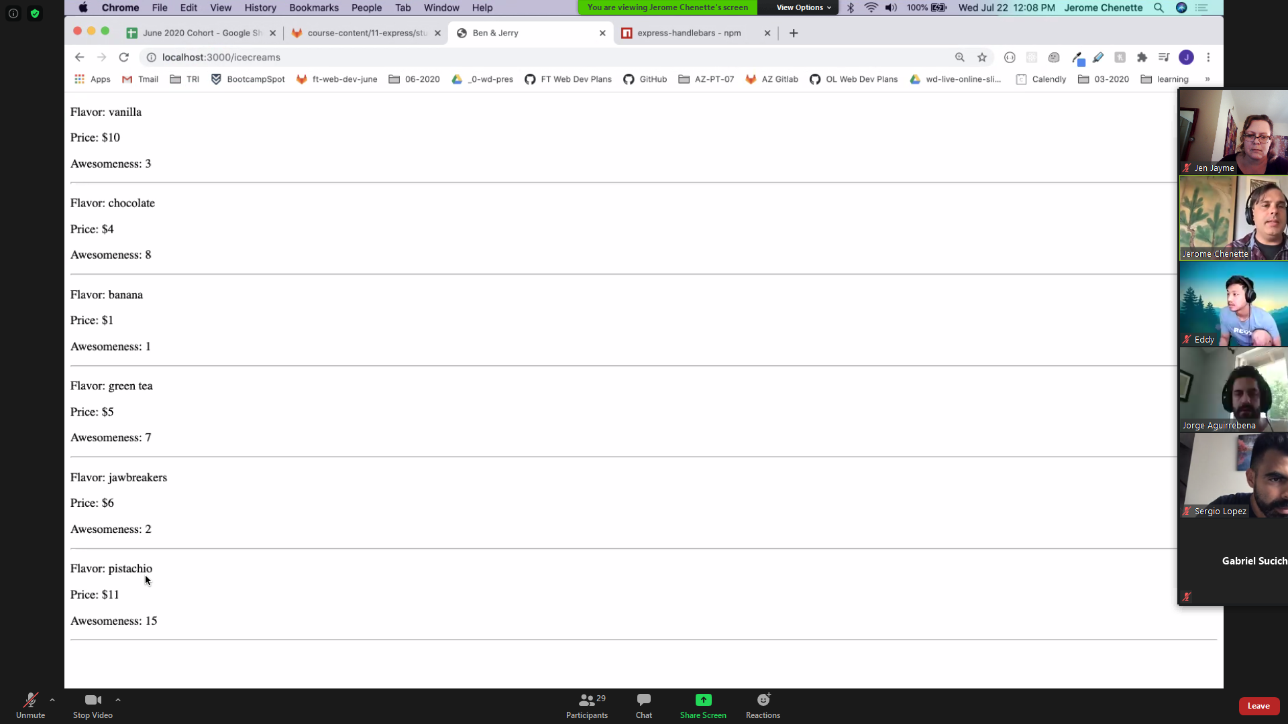

NEED TWO TEMPLATES: SHOW ALL and SHOW ONE

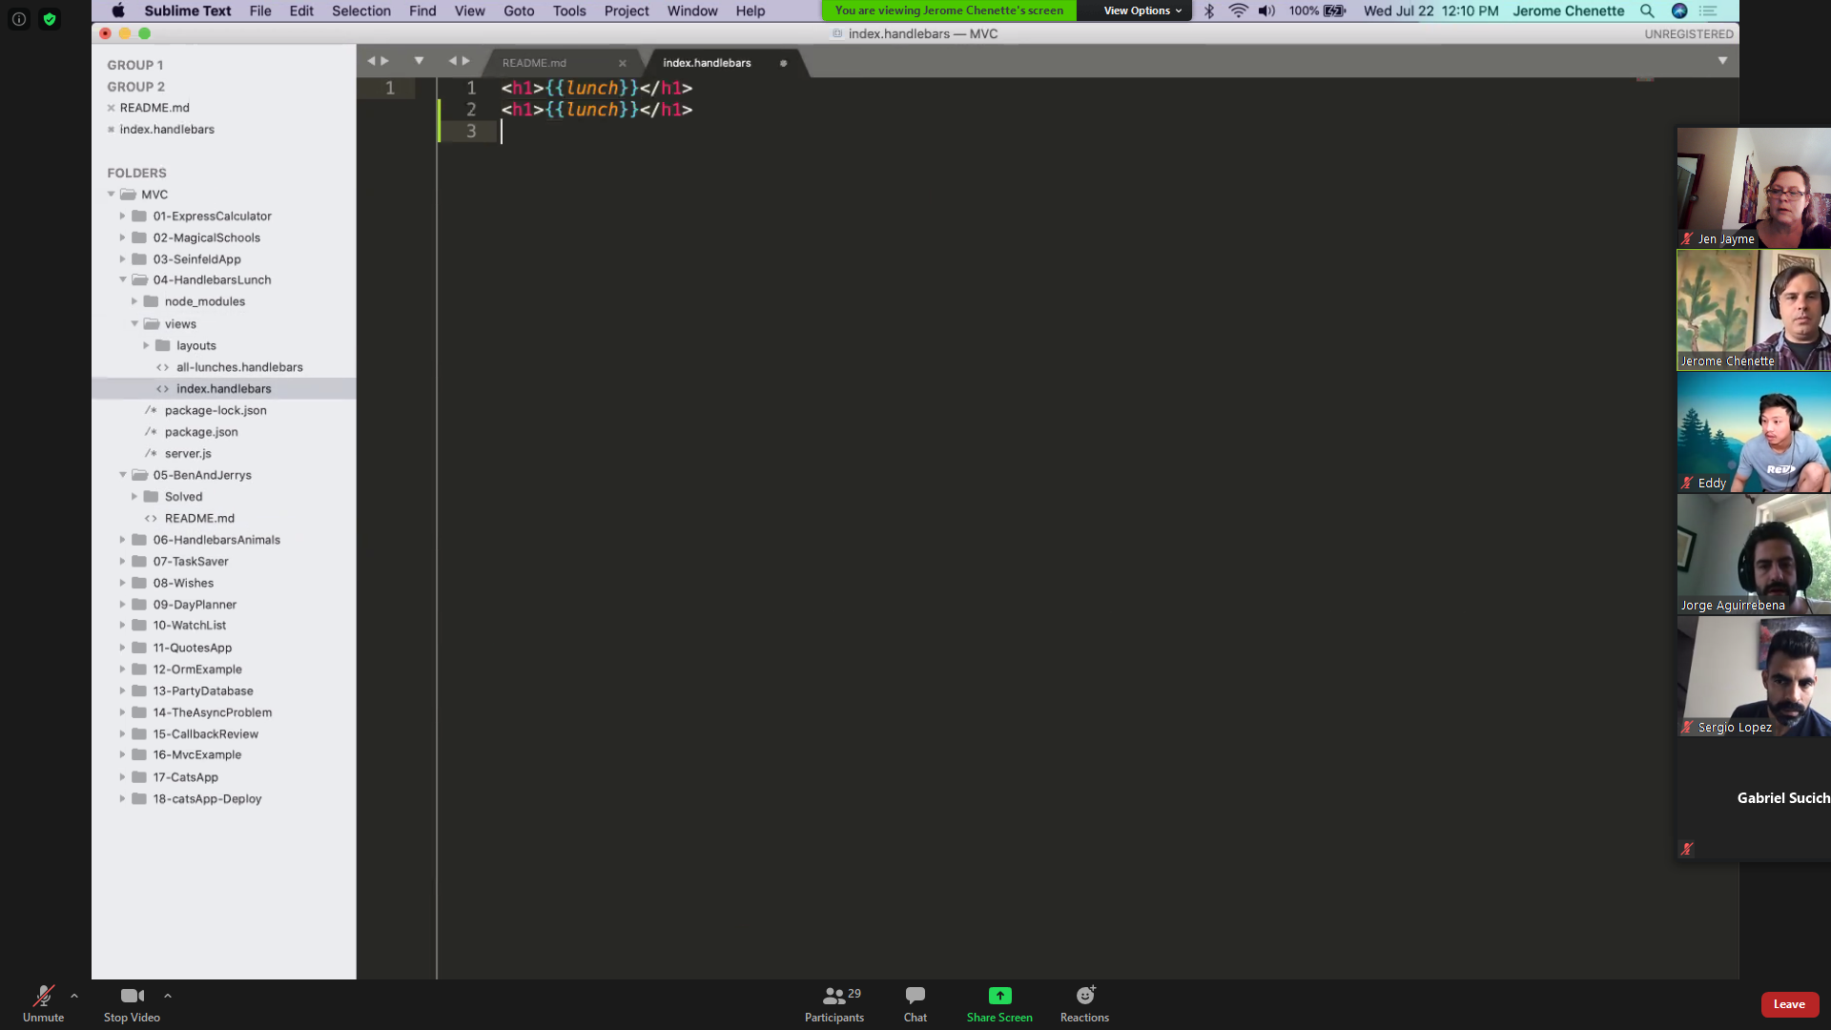

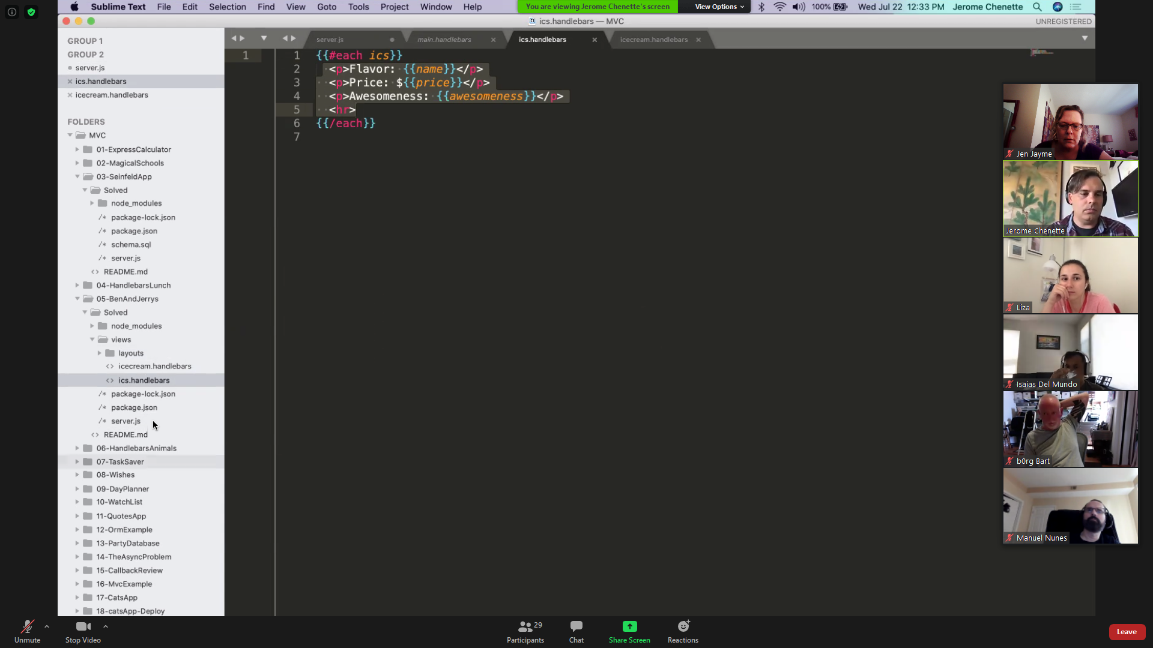

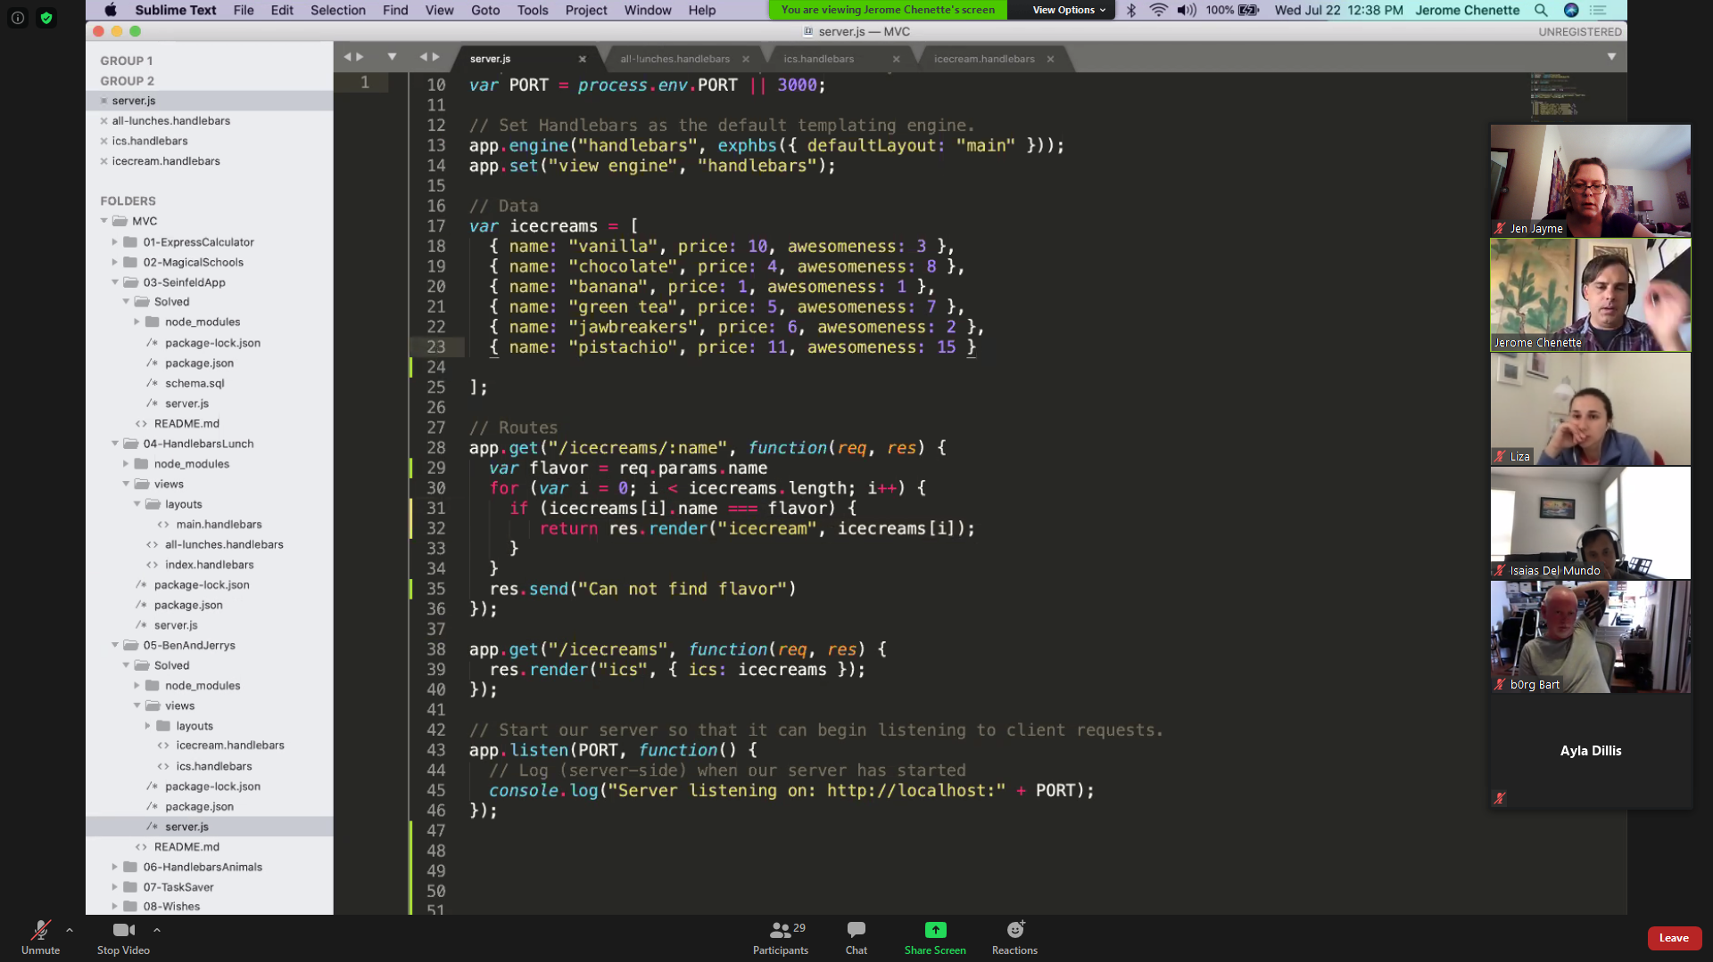

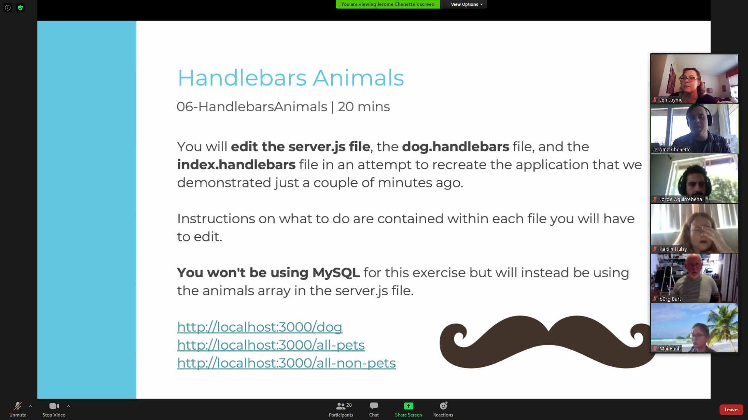

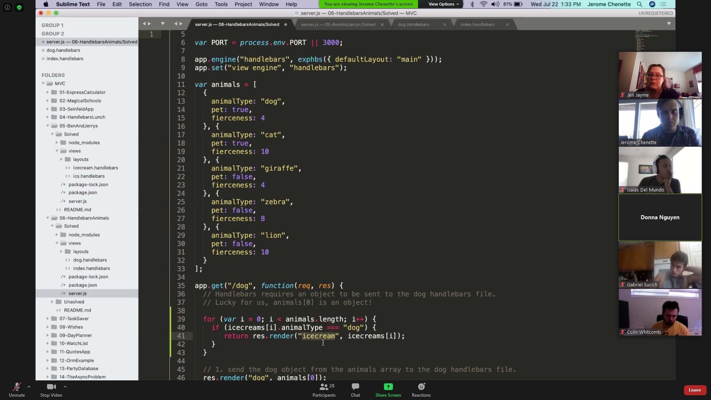

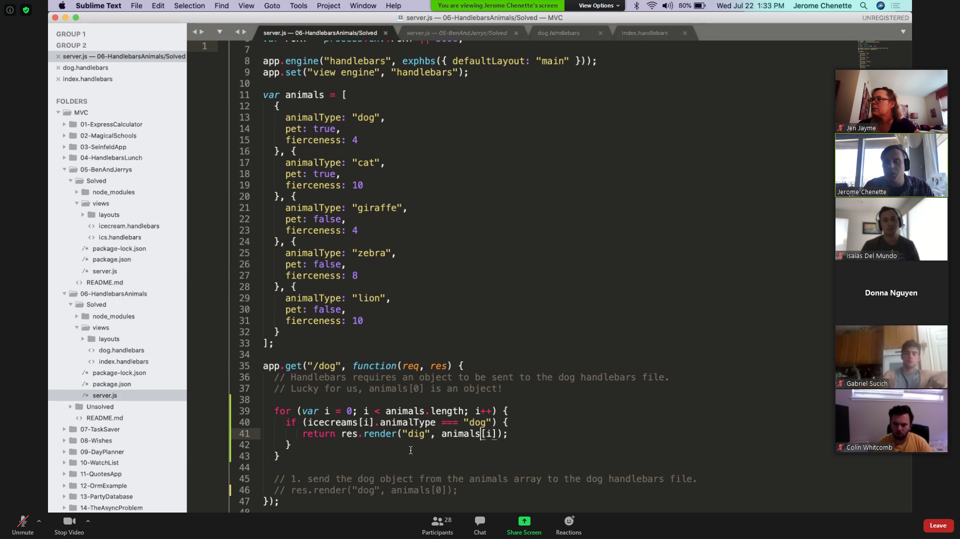

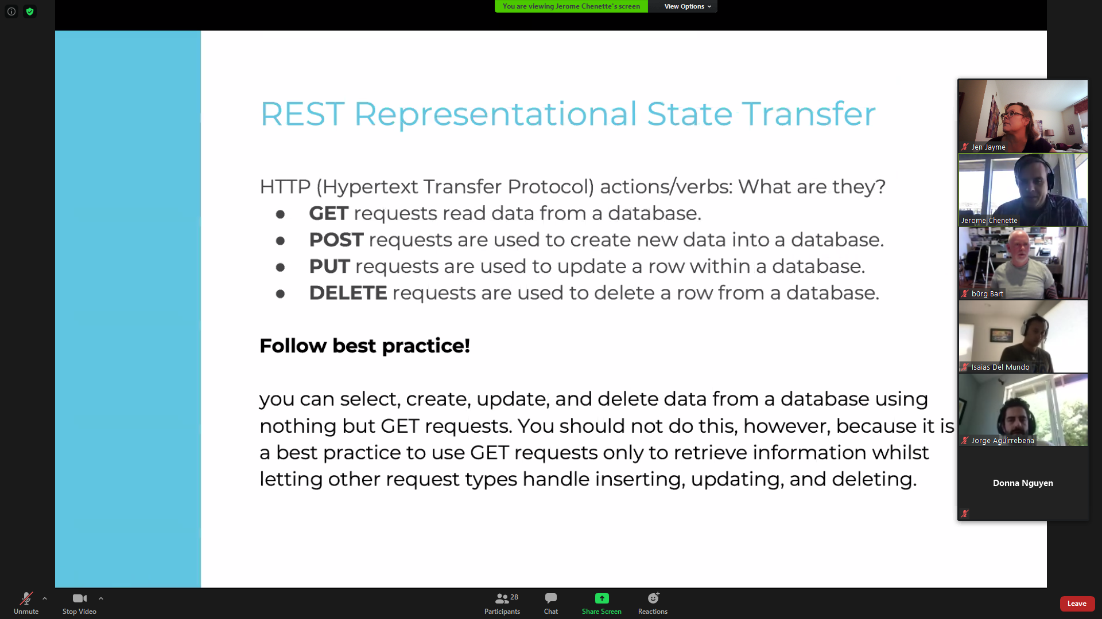

07-TASK SAVER SHOULD LOOK LIKE THIS:

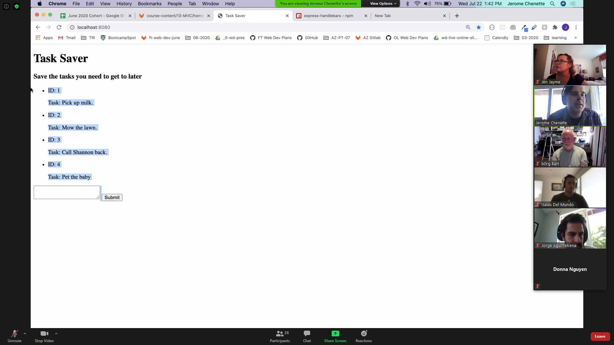

09-WISH SAVER SHOULD LOOK LIKE THIS:  
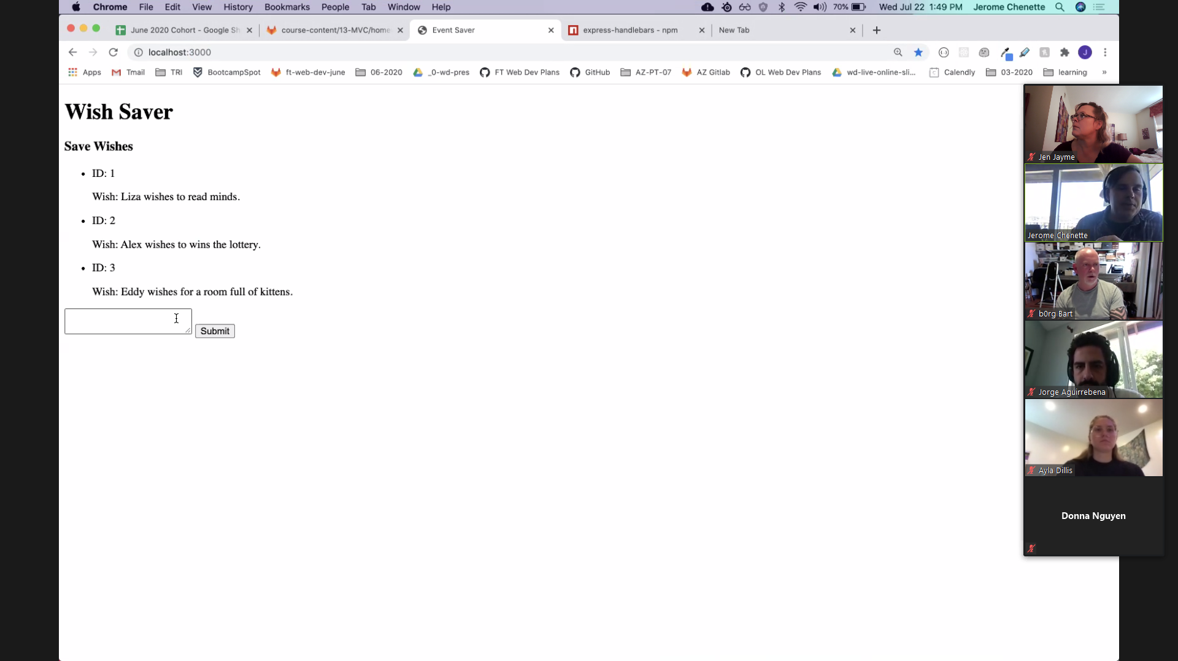

//*FUNCTION TO ADD USER RESPONSES TO DB*

function *addEmployee*(answers) {

    console*.*log("Adding a new employee...\n");

        varquery=*connection.query*(

"INSERT INTO employees SET ?",

{

*first_name*:*answers.first_name*,

*last_name*:*answers.last_name*,

*department_id*:*answers.department_id*,

},

function(*err*,*res*){

if(err)*throw*err;

*console.log*(*answers.first_name*+" "+*answers.last_name*+" employee added to Dunder Mifflin employees database!\n");

*addMore*();

}

);

            //*logs the query being run*

            console*.*log(*query.*sql);

};